MATHEMATICS PAPER 1 UCE
SECTION A
- Express$\frac{8\sqrt{2}}{\sqrt{6}-\sqrt{2}}$in the form a $\sqrt{b}$ + c, hence state the values of a, b, and c.
$\frac{8 \sqrt{2}}{\sqrt{6}- \sqrt{2}}$
= $\frac{8 \sqrt{2} ( \sqrt{6}+ \sqrt{2})}{\left(\sqrt{6}- \sqrt{2} \right) ( \sqrt{6}+ \sqrt{2})}$
= $\frac{8 \sqrt{2} ( \sqrt{6}+ \sqrt{2} )}{(\sqrt{6 )^{2}- ( \sqrt{2} )^{2}}}$
= $\frac{8 \sqrt{2 } ( \sqrt{6 }+ \sqrt{2 } )}{4}$
= 2 $\sqrt{2 } ( \sqrt{6}+ \sqrt{2} )$
2 $\sqrt{12}+ 4$
4 $\sqrt{3}+ 4$
Compare with a$\sqrt{b}+ c$
= a = 4, b = 3, c = 4
- Given that OA= $\left({4 \atop 8}\right)$, OB= $\left({2 \atop 4}\right)$, M is the mid-point of AB and G divides OM in the ratio 2:1. Find the position vector of G.
$\overline{OA}$ = $\left({4 \atop 8}\right)$, $\overline{OB}$ =$\left({2 \atop 4}\right)$
AB = OB =OA
=$\left({2 \atop 4}\right)$ - $\left({4 \atop 8}\right)$ = $\left({-2 \atop -4}\right)$
om = OA + Am
=$\left({4 \atop 8}\right)$ + $\frac{1}{2} \left({-2 \atop -4}\right)$
=$\left({4 \atop 8}\right)$ + $\left({-1 \atop -2}\right)$
0m =$\left({3 \atop 6}\right)$
OG = $\frac{2}{3}$ om
=$\frac{ 2}{3}$ $\left({3 \atop 6}\right)$
0G = $\left({2 \atop 4}\right)$
- Given f(x) = $\frac{3+2x}{x-4}$ , find the value of x for which f⁻¹ (x) is meaningless .
f ($x$) = $\frac{3+2x}{x-4}$
f⁻¹($x)$
Let y = $\frac{3+2x}{x-4}$
y($x-4)$ = 3+ 2$x$.
y$x$ - 4y = 3+2$x$.
y$x-2x=3-4y$
$x$(y-2) = 3 - 4y
$x= \frac{3-4y}{y-2}$
$∴$f¹ ($x)=\frac{3-4x}{x-2}$
F¹=$(x)$ is meaningless when
$$x-2=0$$
$∴$ $x$ = 0
- Factorize completely
- ax²+3abx-3x-9b
ax² + 3abx -3x -9b
ax2 – 3x + 3abx-9b
=x (a x-3) + 3b (ax- 3)
= (ax -3) (x+3b)
- 8x² - 32y²
8x² -32y²
= 8 (x2-4y²)
= 8 (x+2y) (x-2y).
- Find the equation of a line which is perpendicular to the line 3y + 4x = 5 and passing through the mid-point of the $\overline{AB}$ where A(-2,3) and B(4,5).
3y + 4$x$ = 5
3y = -4$x$ + 5
y = $\begin{matrix}-4+ & 5 \\ -3 & 3\end{matrix}$
m¹= $\frac{-4}{3}$
m2 =$\frac{ -4}{3}$, Grad of ……. line
Midpoint m ($\frac{-2+4}{2},$ $\frac{3+5}{2}$ )
m (1,4).
y = m$x$+ c
4= $3/4 x 1+c$
4 = $\frac{3}{4}$ + c
c = 4 - $3/4$ = $\frac{16-3}{4}$ =${ 13}/4$
$∴$ Eqn is
y = $\frac{3}{4}$ x +${13}/4$.
Or 4y = 3x +13

- Mr. Ouma deposited 1.321 million shillings on his bank account at a compound interest rate of 7.5% per annum. Determine the number of years it will take to accumulate 1.764 million shillings.
A = P (1 + $\frac{r}{100}$) ^{n}
1.764 = 1.321 (1+$\frac{7.5}{100}$) ^{n}
$\frac{1.764}{1.321}$ = (1+ 0.075) ^{n}
1.3354 = (1.075) ^{n}
^{n =}$\frac{\log{1.33354}}{\log{1.075}}$
^{n = 3.9993}
^{n} $≅$ ^{4 years}
- Simplify $\frac{1}{3}\log_{10}{64}$ + $\log_{10}{80}$ - 5 $\log_{10}{2}$
$\frac{1}{3}$ Log ₁₀ 64 + log ₁₀ 80- 5 log ₁₀ 2
$⟹$ Log ₁₀ ${64}^{\frac{1}{3}}$64 + log ₁₀ 80- 5 log ₁₀ $2^{5}$
$⇒$Log ₁₀ 4 + log ₁₀ 80 – log ₁₀ 32
$⇒$ Log ₁₀$(\frac{4 x 80}{32}$)
$⇒$ Log ₁₀10
$⟺$ 1.
- Given that A = $\left\{the first five multiples of two\right\}$
B = $\left\{the first ten counting numbers\right\}$
- List the members of sets A and B
A = {2, 4, 6, 8, 20}
B = { 1,2,3,4,5,6,7,8,9,10 }
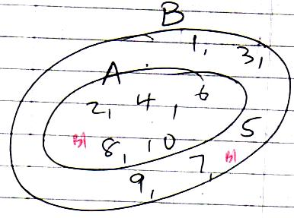
- Represent the two sets on a Venn- diagram.

- Find the lowest common multiple (L.C.M) and the highest common factor (H.C.F) of 54 and 84
2 | 54 | 84
2 | 27 | 42
3 | 27 | 21
7 | 9 | 7
9 | 9 | 1
 | 1 | 1

$∴$ H.C.F = 2X3
= 6
L.C.M = 2² x 3 7 x 9
= 756

- Find the value of x given that$\log_{10}({3x+4)- \log_{10}{(3x-1)=1}}$.
C = K and C x N
C = K and C = RN
$∴$ C =K + RN.

SECTION B
- The cost per week of running a private school is partly a constant and partly varies directly with the number of pupils. It costs shs. 350,000 a week when there are 50 pupils and shs. 600, 000 a week when there are 100 pupils in the school if C is the cost and N is the number of Pupils.
- Find the cost of running the school with 250 pupils a week.
350.000 = K + 50R – (i)
600.000 = K + 100R-(ii)
Solving simultaneously,
250,000 = 50R
R = 5000
350,000 = K + 250,000
K = 100,000
$∴$ C = 100,000 + 5000 N.
$∴$ For N = 250,
C = 100,000 + 5000 X 250
= Shs. 1,350,000
- If in a certain week shs. 750,000 was spent,determine the number of pupils that attended that week
C = 750, 000, N=?
C = 100,000 + 5000 N
750,000 = 100,000 +5000 N
5000N = 650,000
N = 130
$∴$ 130 pupils

- A group of 36 boys were asked which games they played from foot ball (F),Volley ball (V) and tennis (T) it was discovered that 12 play F, of which 2 play F and T only. An equal number of boys play V and T. 6 play F and V while 5play all the games. Those who play V and T only are one less than those who play F only and half those who did not play any of the three games.
- Represent this information on a Venn diagram
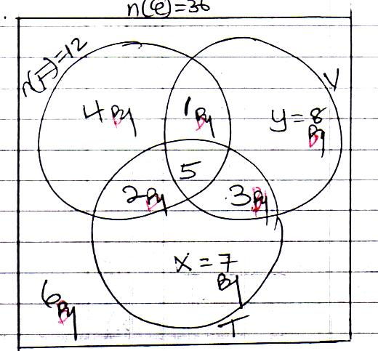
n (F) only = 12 –(2 +5+1) = 4
n(v) = n(T)
y+ 145+ 3 + X+2+5+3
y+ 9 = x+ 10
y- X = 1. (1)
$⟹$ y = x + 1
Also
4+1+2+5+3+x+y+6 =36
21+ x +x+1 =36
2x +22 =36
2x =14
x =7
$∴$ x=7, y =8
- Find the number of boys who play
- Tennis
17 boys
- Only one game
19 boys
- What is the probability that a boy chosen at random plays at most two games.
n (play at most one game )
=4+8+7+6
=25
Prob =${25}/{36}$

- Town A is 130km from town B. A coaster left town A at 9.30am and because of jam it moved at a speed of 10kmh⁻¹ for the first 1 hour. It then covered the next 90km in 1 ¼ hours before developing a mechanical problem which was rectified in 15 minutes. The coaster then sets off again and arrived at town B at 12:30pm.
- Draw a distance – time graph showing the motion of the coaster.
(Use, scales of 1cm: 10km and 4cm: 1 hr)
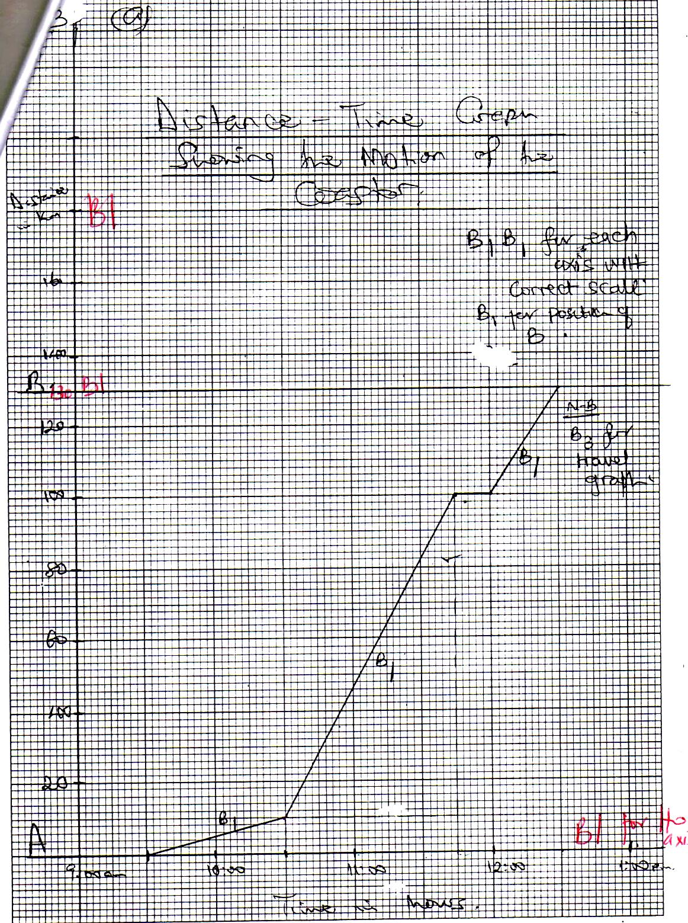

b) Find the speed of the coast
- Before getting a mechanical problem
Speed = $\frac{D}{T}$
=$1_{4}^{1}$
= 72 km h ⁻1
- After rectifying the mechanical problem.
Speed =$\frac{ 30}{\frac{1}{2}}$
=$\frac{130}{3}$
= ${43}_{3}^{1}$ km h⁻1

c. Find the average speed of the coaster over the whole journey.
Average speed = $\frac{Total distance }{Total time }$
=$\frac{130}{3}$
=${43}_{3}^{1}$ km h ⁻1

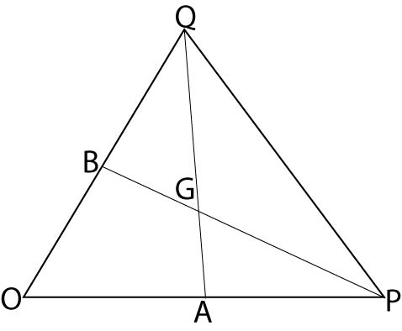

In the figure above
OPQ is a triangle such that

OA = 3a, OB= 3b and OP = 2OA, OQ= 2OB, 3AG= $2AQ$ and 5PG= 3PG
- Find in terms of a and b the vector
- AB = AO+ OB, or OB –OA
=-39+3b
Or 3b -39

- PQ =PO +OQ OR OQ-OP
=⁻20A +20B
⁼ ⁻6a +6b
Or 6b -6a
- OG = OA +AQ
but from 3AG =2 AQ
AG =$\frac{2}{3}$ AQ
and
AQ = AO + OQ
=-3a+ bb
$∴$ AG =$\frac{2}{3}$ (-3A+6b)
= -29+ 4b.
$∴$ OG = 3a +-2a + 4b
= 3a -2a+4b
= a+ 4b
From 3 AG =2AQ
AQ =$\frac{3}{2}$ AG
=$\frac{3}{2}$(OG –OA)
=$\frac{3}{2}$ $⟦(a+4b)$-3a)
AQ = $\frac{3}{2}$ (a+4b -3a)
= $\frac{3}{ 2}$(⁻2a + 4b)
=3(⁻a+ 2b)
=⁻3a+6b.

- Show that A, G and Q are collinear.
A, G, Q collinear
AQ =⁻3a +6b
AG= $\frac{2}{3}$ AQ
=$\frac{2}{3}$(⁻3a + 6b).
AG and AG are parallel.
Since AG and AQ have common point, A, G, Q are collinear.

- The table below shows the tax structure on taxable income of a certain working class of people

Income (shs) per month | Rate of tax (%)
15,001 – 40,000 | 8.00
40,001 – 70,000 | 12.50
70,001 – 120,000 | 15.50
120,001 – 200,000 | 24.00
200,001 – 350,000 | 30.00
350,001 – 420,000 | 35.00
420,001 – 500,000 | 45.00
Above 500,000 | 48.00

An employee earning a gross income of shs 7,200,000 per annum is allowed the following;
Allowance Amount
Transport and lunch 45,000 per month
Housing 960,000 per annum
Water and electricity 25,000 per month
Medical care 900,000 per annum
Marriage $\frac{1^{th}}{20}$ of gross monthly income

The employee is allowed a family allowance for any three children according to the age distribution

Age | Amount (shs)
0 – 12 | 9000
13 – 18 | 5000
19 – 21 | 3500
22 – 25 | 2000

Given that this employee has a family of five children aged 23 years, 20 years, 17 years, 15 years and 8 years.
- Calculate the employee’s income tax.
Gross monthly income = $\frac{7,200,000}{12}$
= shs. 600,000
Allowances
Transport and lunch 45,000
Housing $\frac{960,000}{12}$ 80,000
Water & electricity 25,000
Medical $\frac{900,000}{12}$ + 75,000
Marriage $\frac{1}{2}$x 600,000 30,000
Children 9000 + 2x 5000 19,000
Total allowances = 274,000
Taxable allowances =
Gross income – Allowances
= 600,000 – 274,000
= shs.326, 000.
Income tax;
Taxable income Tax
The 1st 15,000/= 0
On next 25,000/= $⟹$ $\frac{8}{100}$ x 25,000 = 2,000
Next 30,000/=$\frac{12.5}{ 100}$ X 30,000 = 3,750
Next 50,000/= $⇒ \frac{15.5}{100 }$ x 50,000 =7,750
Next 80,000/=$⇒$ $\frac{24}{100}$ x 80,000 =19,200
Next 126,000/= $⇒$ $\frac{30}{100}$ X 126,000 =37,800
$∴$ Total income tax = 2000 +3,750 + 7,750 +19,200 + 37,800
= Shs .70, 500
- Determine the percentage of the employees taxable income that goes to tax
= $\frac{tax}{taxable income }$ X 100%
= $\frac{70,500,}{326,000}$ x 100%
= 21.6258%
$≅$ 21.63%

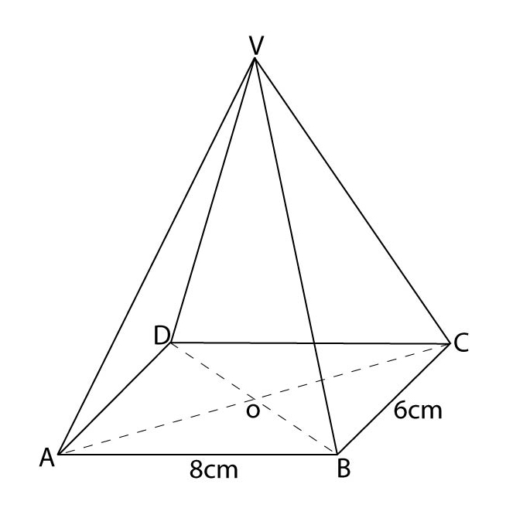

In the figure above $\overline{VA}$= $\overline{VB}$ = $\overline{VC}$= $\overline{VD}$
$\overline{AB}$= 8cm, $\overline{BC}$= 6cm and V is vertically above O. If$\overline{VO }$= 12cm, find
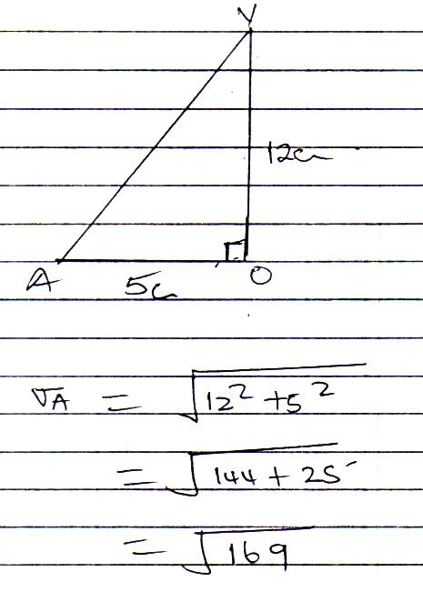
- The length VA
AC = $\sqrt{8^{2}+6^{2}}$
=$\sqrt{100}$
=10cm

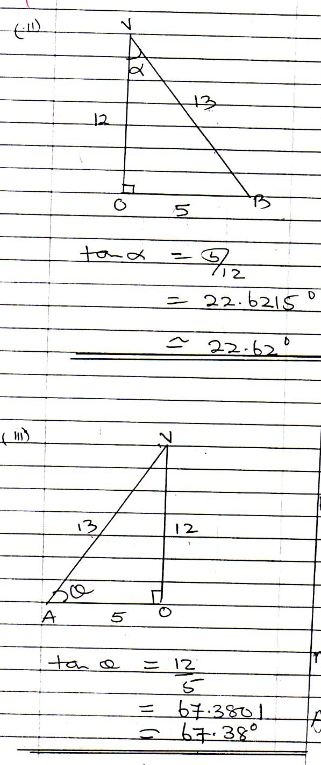
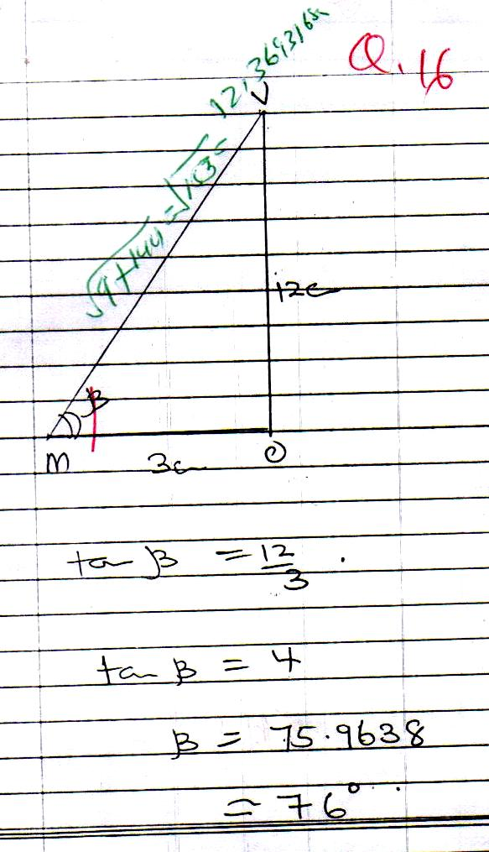
- The angle between the planes VAB and ABCD

- (a) Given the functions f(x) = $\frac{x+3}{2}$ and g(x) = $\frac{1-2x}{5}$, determine the values of x for which
fg($x$) = $\frac{9+24x+8x^{2}}{10}$

f ($x$) = $\frac{x+3}{2}$
g ($x$) =$\frac{1-2x}{5}$
fg ($x$) =f $\frac{\left(1-2x\right)}{5}$
=$\left\{\begin{aligned}1-2x \\ 5\end{aligned}\right.$ +3 $÷$ 2
=$\frac{1-2x+15 }{5}$ X$\frac{1}{2}$
=$\frac{16-2x}{10}$.
$\frac{16-2x}{10}$ =$\frac{9+24x+8x^{2}}{10}$
16-2$x$=9+24$x$+8$x$²
8$x$²+ 24$x$ +9=16-2$x$
${8x }^{2}$+24$x$+2$x$ +9-16=0
$x=$⁻$26\underline{+}$
$x=-_{26} \underline{+}$

(b) If P:Q = 3:4 and Q:R = 1:2 and that P+Q+R = 30,000. Find
(i) The ratio P:Q:R
P: Q = 3:4
Q:R=1:2
$\frac{P}{Q}$ = $\frac{3}{4}$
$\frac{Q}{R}$ = $\frac{1X4}{2X4 }$ = $\frac{4}{8}$
$P:Q:R=$ 3:4:8.

(ii) The proportional parts of P,Q and R

A+ B+ C= 30,000
Total share =15
A gets $\frac{3}{15}$ x 36,000
= shs 6,000
B gets $\frac{4}{15}$ x 30,000
= shs 8,000
C gets $\frac{8}{15}$ x 30,000
=shs 16,000

END

